dIGITAL SYSTEM DESIGN (CE2003) LAB 4 REPORT

By

Chew Zhi Jie - U1520864B

Dr. Douglas Maskell

FEP 1

March 8, 2016

**outline description of the experiment design**

* **Background information**
  1. Pixel colour is typically represented as red, green, and blue components; RGB. While other colour like CMYK colourspace which is used in print publishing, where four (additive) components are combined to create any color.
  2. Another alternative is the YUV colourspace, which better takes human vision into account. Here, the Y represents the luminance, or brightness of a pixel, and is equivalent to the black-and-white representation of an image. The U and V components are colour difference signals that encode colour information.
  3. It turns out that detecting skin colour in the YUV colourspace is more eﬃcient. In this experiment, we will convert RGB signals from a camera to YUV to determine skin pixels and then apply a colour shift.
* **Experiment Design**
  1. Files to instantiate Camera and HDMI as well as transferring data from camera to HDMI with processing module are given.
* **Experiment Objective**
  1. Student are required to do the following:
     1. Build a colourspace conversion circuit
     2. Include the circuit in a pre-designed system to convert video pixels
     3. Apply some basic logic to detect skin regions and alter those pixels

**rgbyuv module**

* **Code**

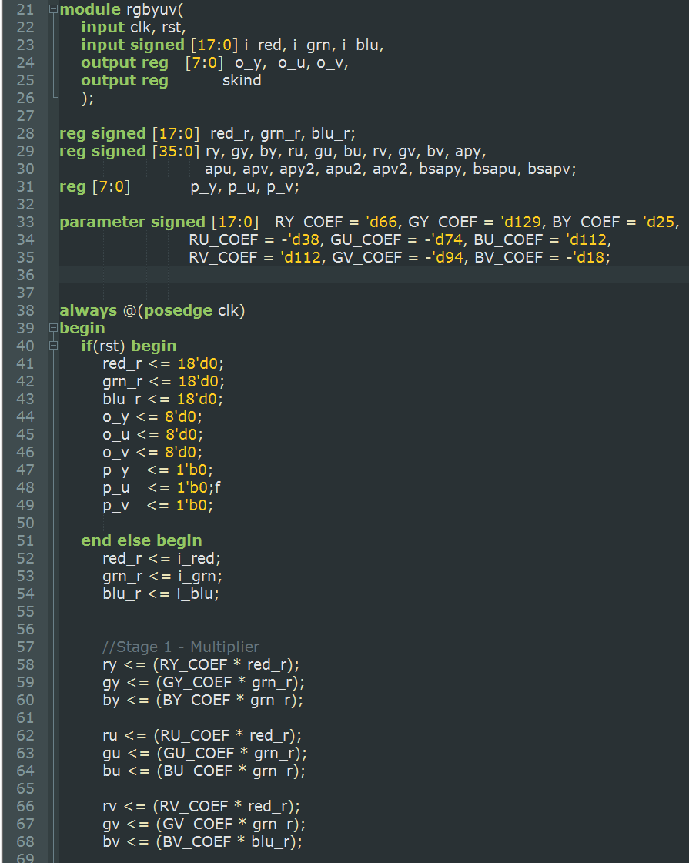

**Line 21-26:**

Module Declare: input and output

**Line 28-32:**

Variable Declaration: Registers for pipelining

**Line 33 -35:**

Parameter Declaration:

Coefficient to convert from RGB to YUV

**Start of synchronize always block:**

**Line 40 -51:**

Reset all values to 0 if rst is high

**Line 52 – 54:**

Latch inputs into inputs register

**Line 58 – 68:**

**1st** Stage Pipelining: Multiplication of RGB input with coefficients

**Line 70 -73:**

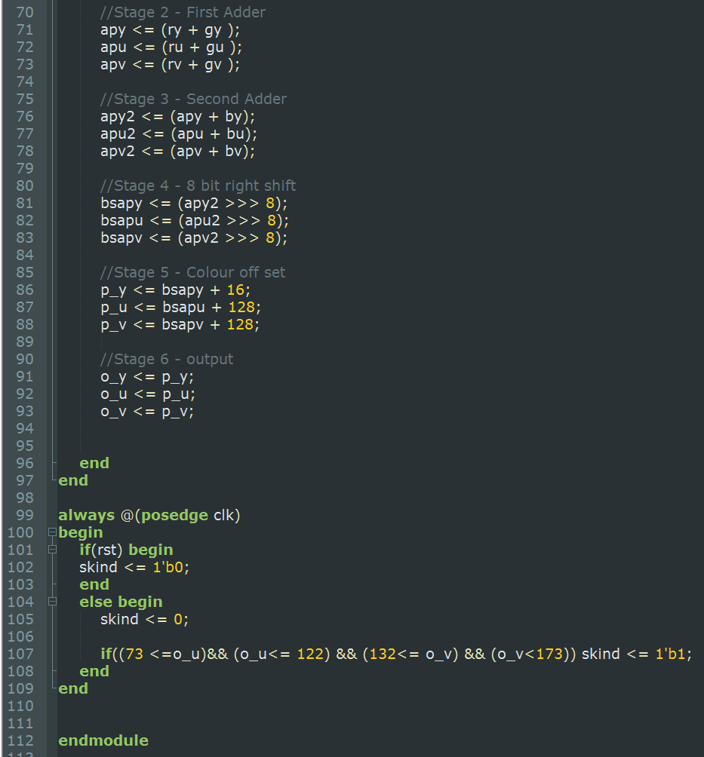

**2nd** Stage Pipelining:

Adding two outputs from the multiplier

**Line 75 -78:**

**3nd** Stage Pipelining:

Adding third output from the multiplier to the output from 2nd Pipeline

**Line 80-83:**

**4nd** Stage Pipelining:

Doing a 8-bit right shift to the outputs from 3rd pipeline

**Line 85-88:**

**5nd** Stage Pipelining:

Adding colour offset to outputs from 4th pipeline.

**Line 90-93:**

**6th** Stage Pipelining: Get the output from 5th pipeline and latch it to the output of the module

**Line 99- 109:**

Another synchronize that will reset skind to 0 if rst is high. Else it will check is o_u between 73 and 122 and is o_v between 132 and 173. When the above condition satisfies, skind will be set to high. If condition isn’t met, skind is low.

### Diagram

o_y

o_u

o_u

p_u

p_u

p_y

Colour Offset

Pipeline 6 - Output

8’d128

8’d128

8’d16

bapv

bapu

bapy

**>>>8**

8 Bit-shift

Pipeline 5 – Colour Offset

**>>>8**

**>>>8**

apv2

apu2

Adder 1

Adder 2

apy2

apv

apu

apy

bv

by

bu

bv

gv

rv

ru

gu

bu

by

gy

ry

red_r

RY_COEF

GY_COEF

BY_COEF

Pipeline 4 – 8 bit right shift

Pipeline 3 – Second Adder

Pipeline 2 – First Adder

grn_r_r

RU_COEF

GU_COEF

BU_COEF

blu_r_r

GV_COEF

RV_COEF

BV_COEF

Pipeline 1 - Multiplier

Multiplier

* Rgbyuv circuit circuit
  + Frequency achieved : 384.601Mhz
  + Number of pipeline stages : 6
  + Number of multipliers used : 9

**A description of what the delay_line module does**

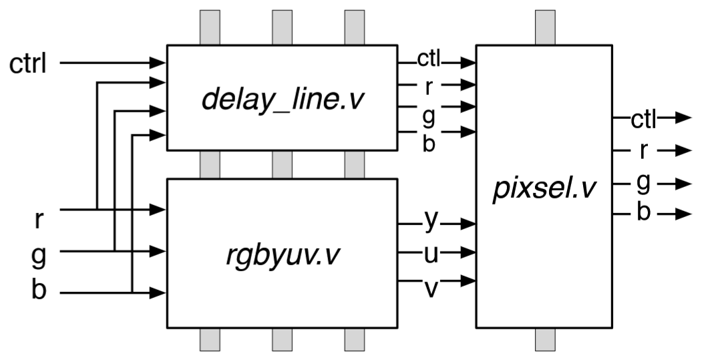

From the diagram above, if there is no delay line module. Ctrl, r, g, and b will be feed into pixsel module directly. However, this will impose an issue as rgbyuv takes 7 clock cycle to generate y, u and v output for the pixsel. Hence, delay line is use to delay the Ctrl, r, g, and b input. So that the correct ctl, r, g, b, y, u, v will arrive at pixsel at the same clock cycle. This is why we insert 6 pipeline delays into the delay_line to delay the r, g, b and ctrl inputs.

**A description of the pixel module and how it works**

Pixel determines the input of the switch from FPGA board and streams the corresponding output.

**Default Case:**

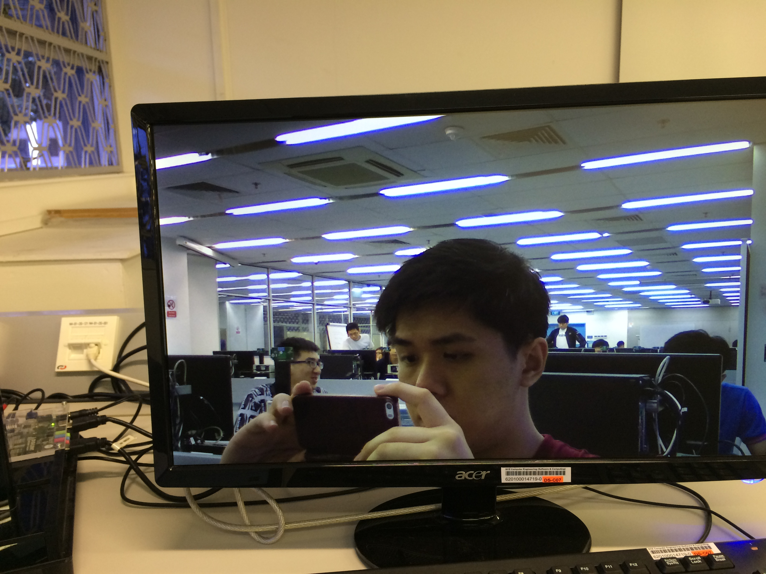

Output is default

RGB

**First switch:**

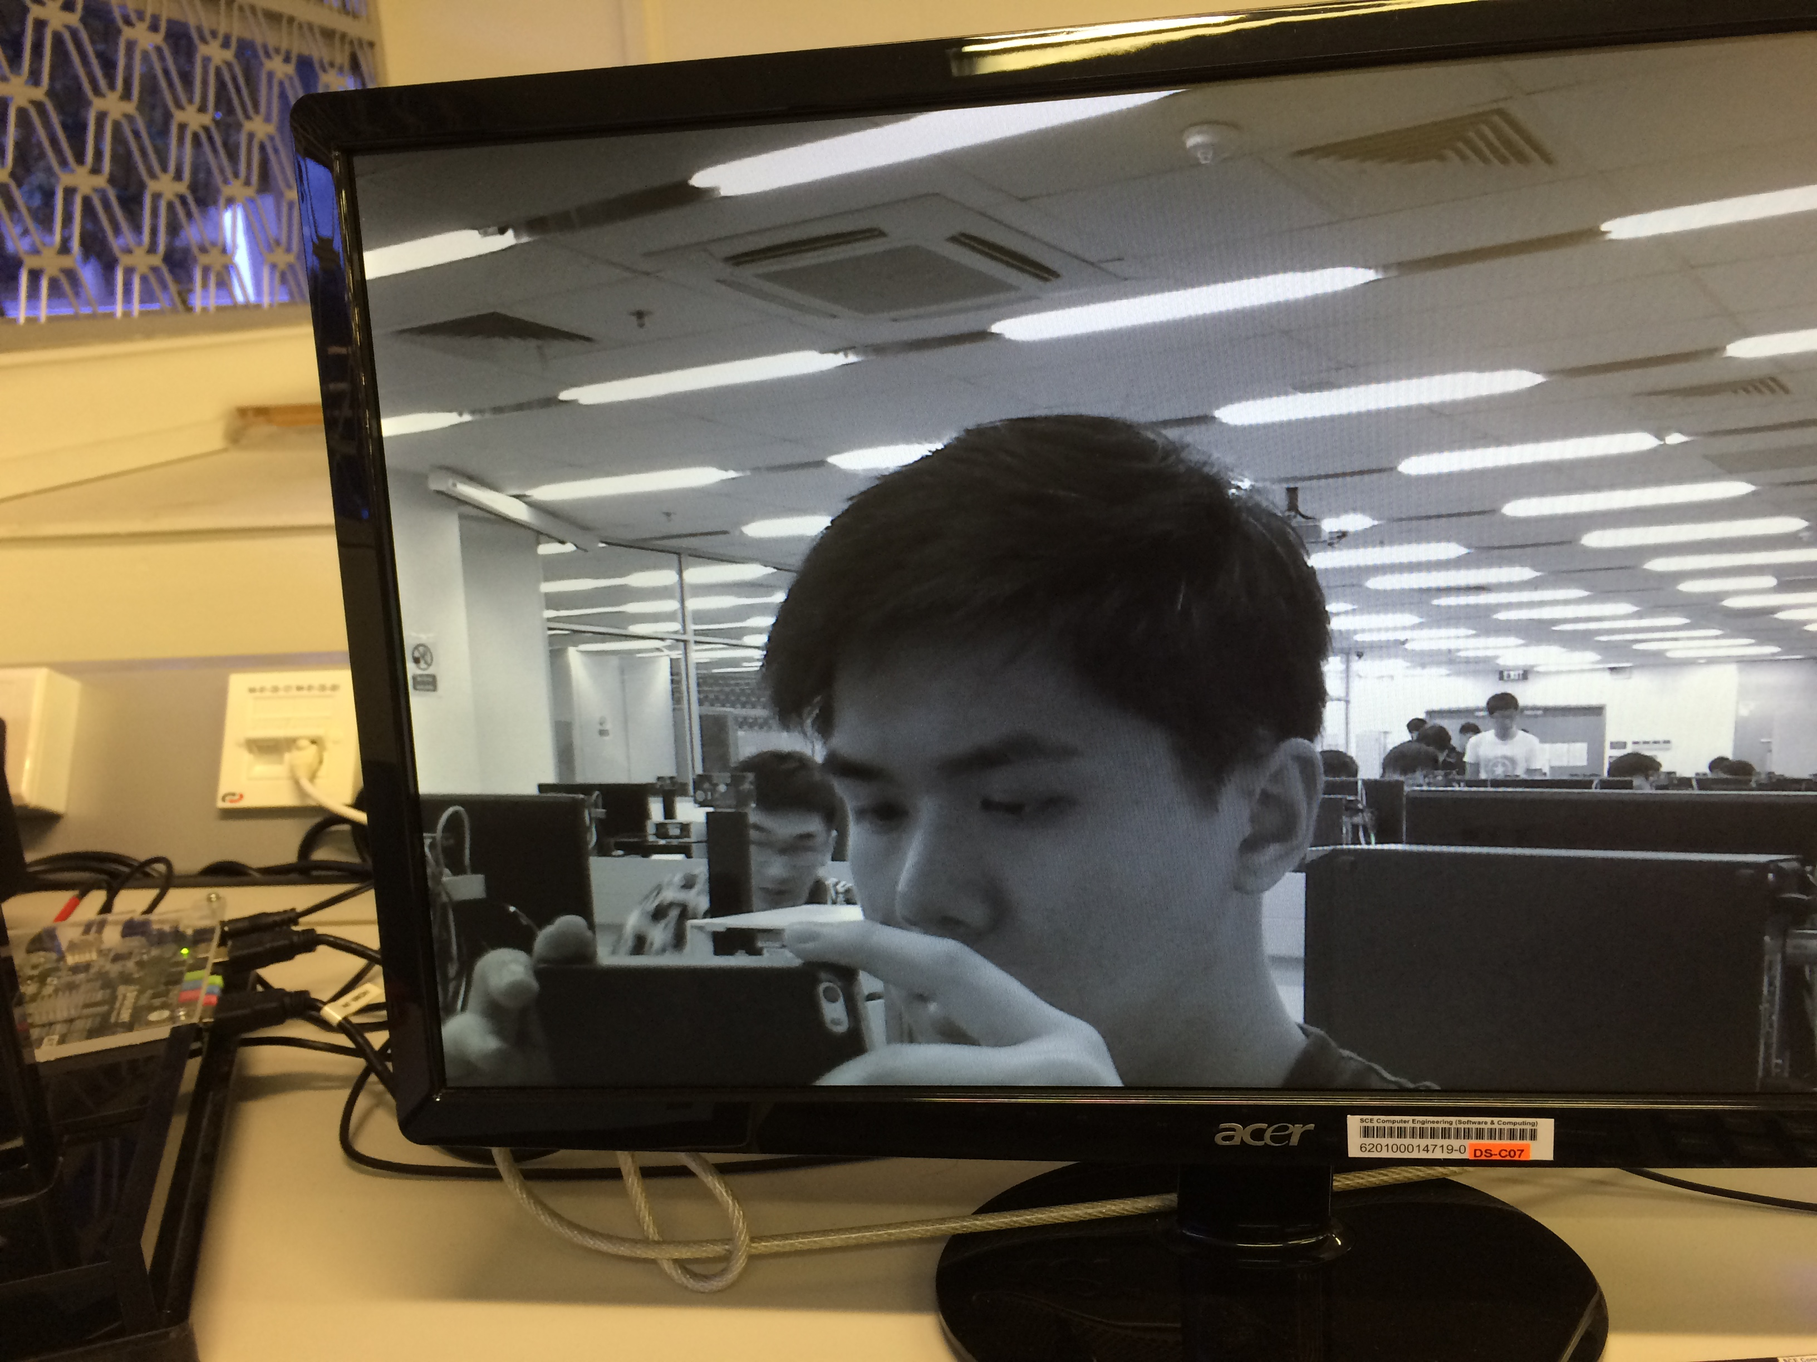

Output Y to all RGB

which Y is the

brightness of the

pixel

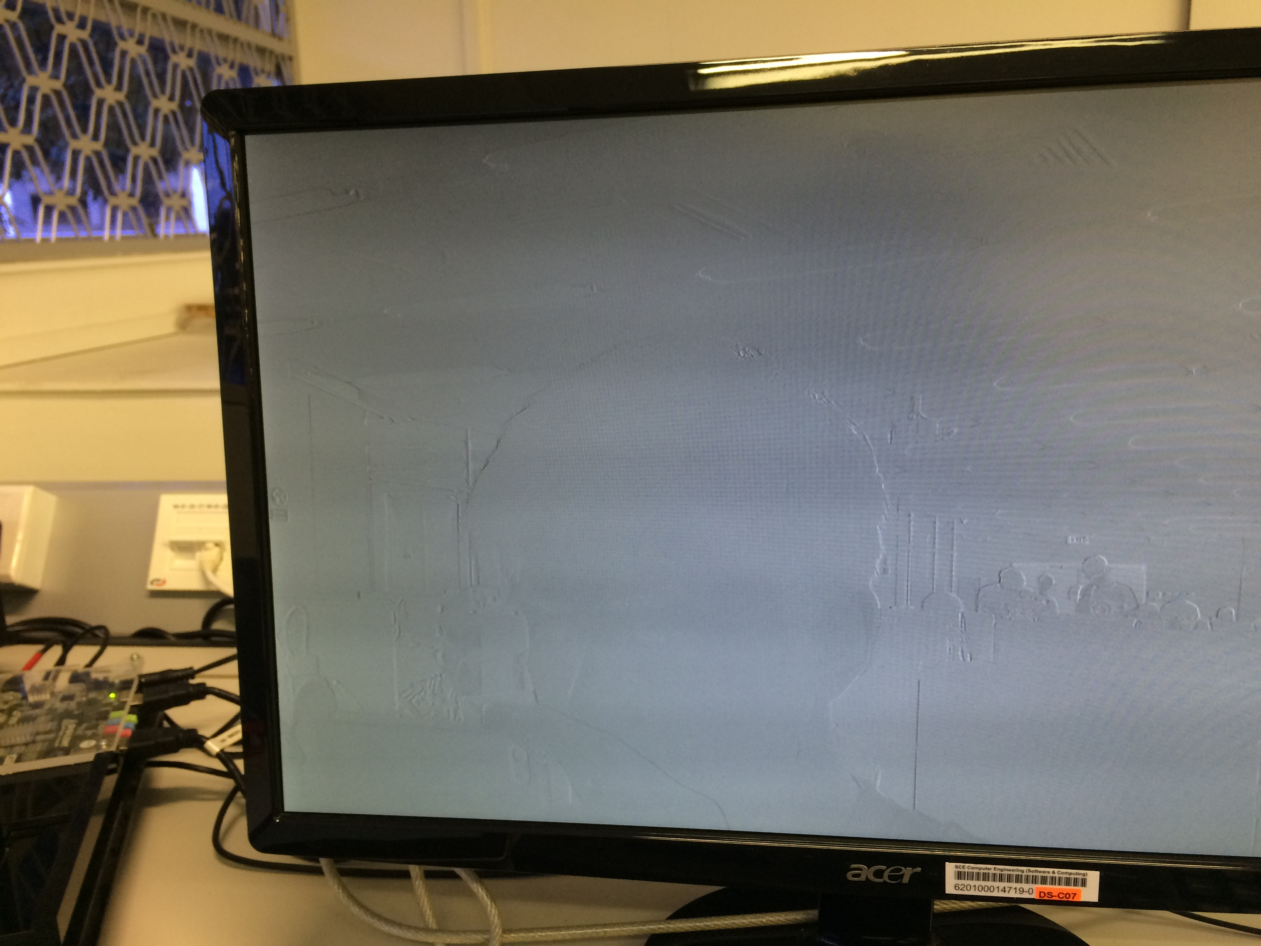

**Second switch:**

Output U to all RGB

which U and V are

colour encoding

**Third Switch:**

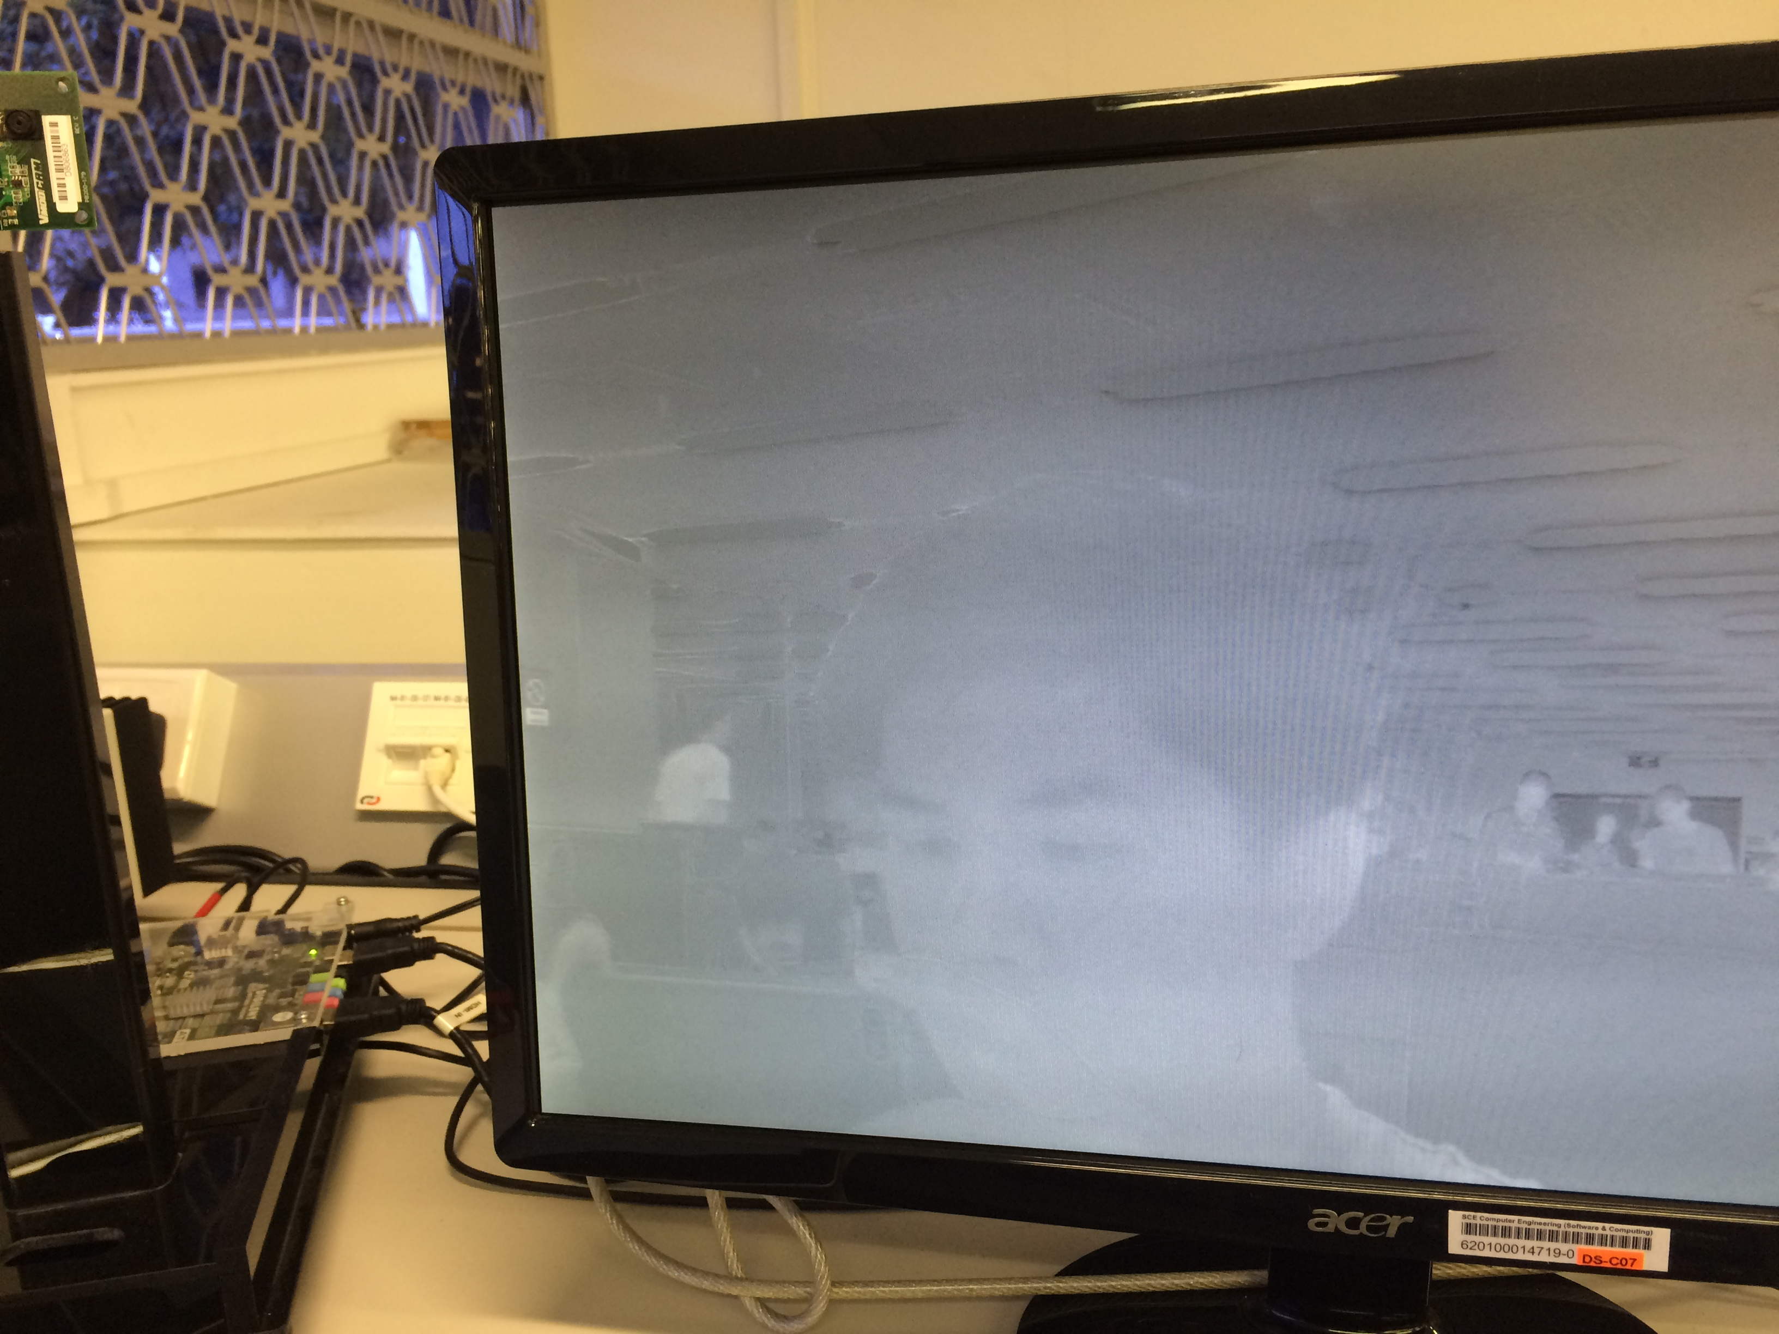

Output V to RGB

which U and V are

colour encoding

**Fourth Switch:**

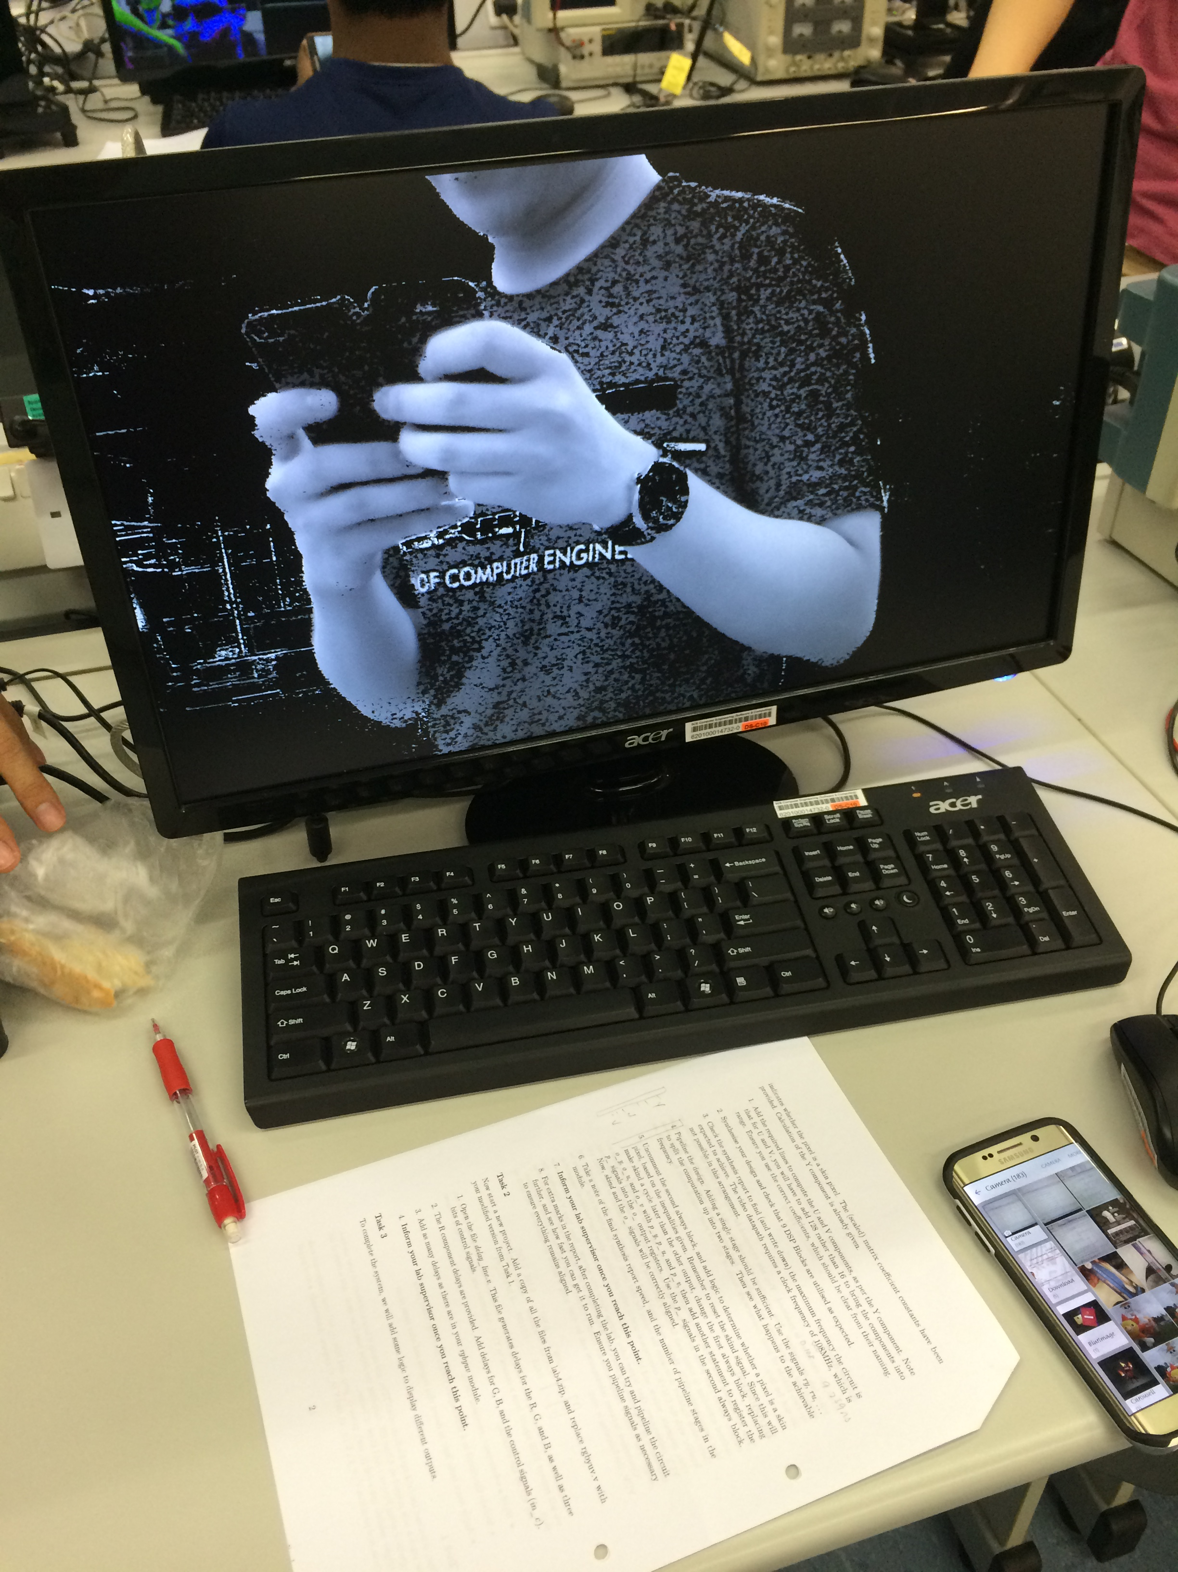

If in_skin is true,

Output Y to all RGB

which Y is the

brightness of the

pixel

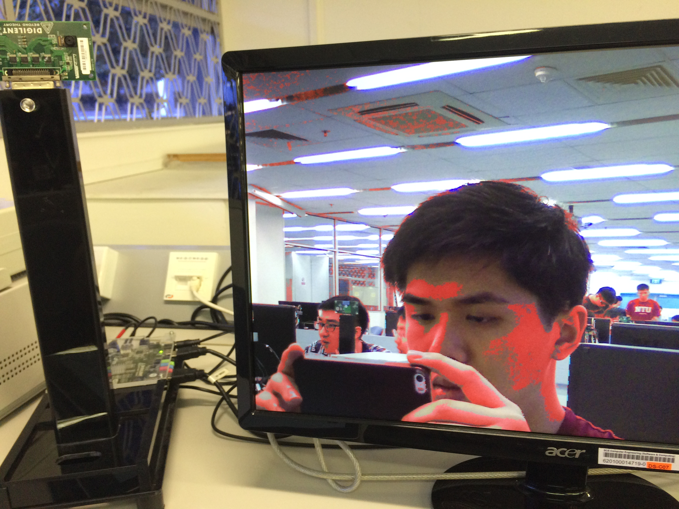

**Fifth Switch:**

If in_skin is true, min_r, max_g,

ouput the min_r, max_b defined

max_g, max_b to below

RGB respectively

**Sixth Switch:**

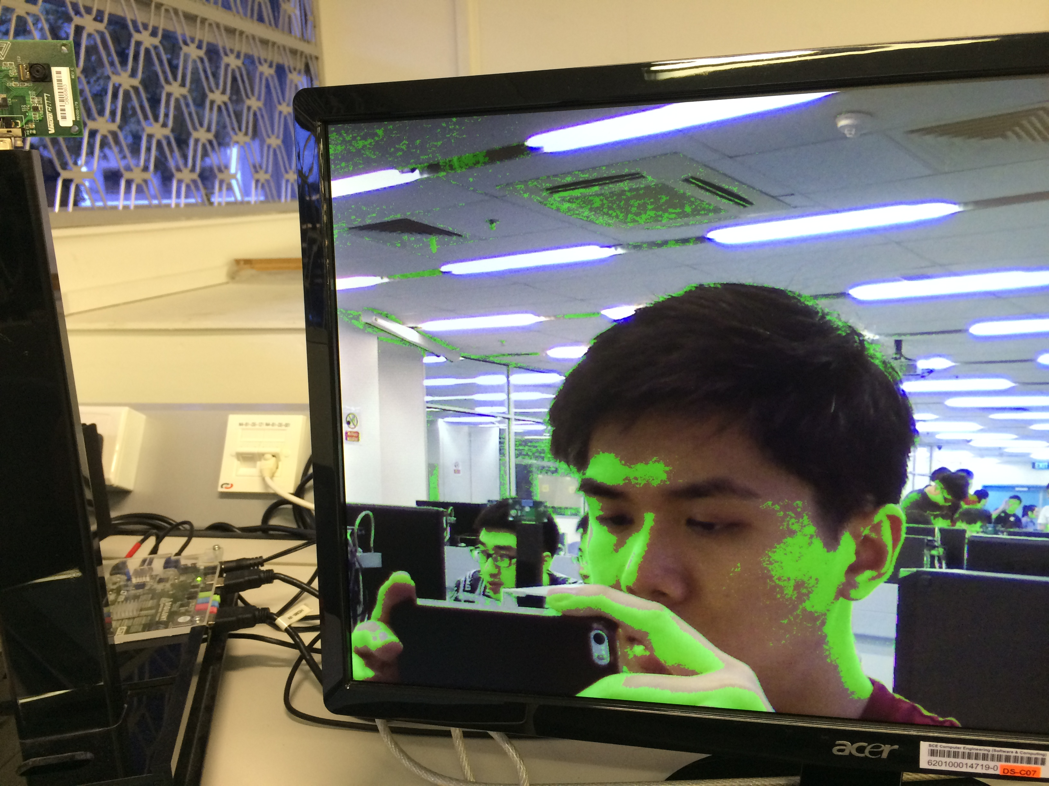

If in_skin is true, max_r, min_g,

ouput the max_r, min_b defined

min_g, min_b to below

RGB respectively

Else output normal

RGB

**Seventh Switch:**

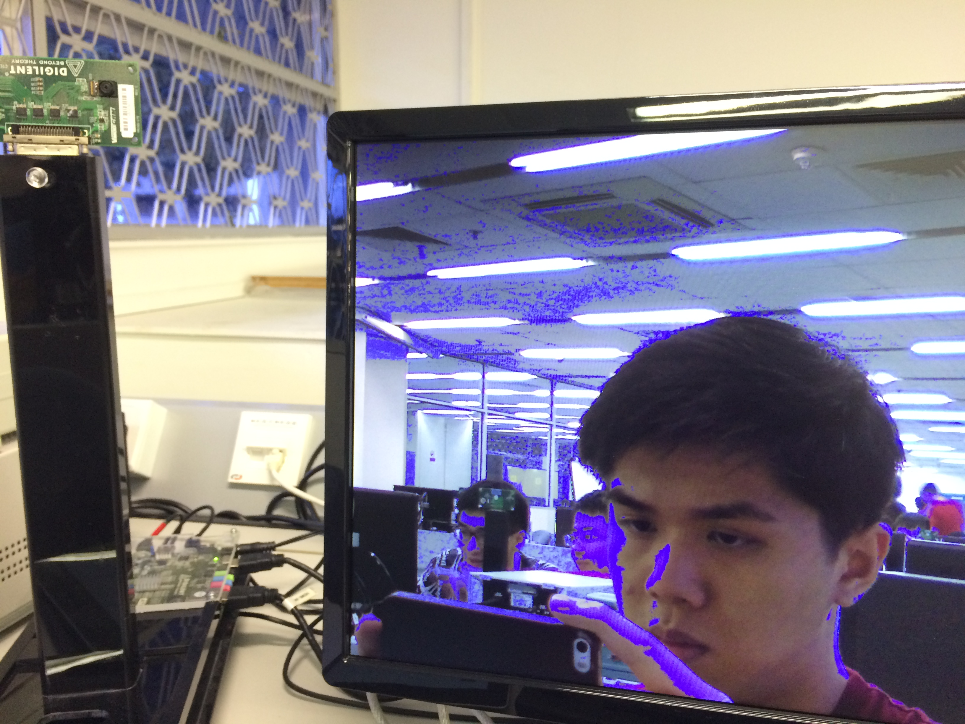

If in_skin is true, min_r, min_g, max_b

ouput the min_r, defined below

min_g, max_b to

RGB respectively

Else output normal

RGB.

wire [8:0] **max_r** = ((in_r + 64)<255) ? in_r + 64 : 255;

wire [8:0] **min_r** = ((in_r - 32)>0) ? in_r - 32 : 0;

wire [8:0] **max_g** = ((in_r + 64)<255) ? in_g + 64 : 255;

wire [8:0] **min_g** = ((in_r - 32)>0) ? in_g - 32 : 0;

wire [8:0] **max_b** = ((in_r + 64)<255) ? in_g + 64 : 255;

wire [8:0] **min_b** = ((in_r - 32)>0) ? in_g - 32 : 0;

**Personal Reflection**

From the lab, I learnt that color can be represented by RGB, CYMK and YUV colourspace. Each colour representation has its usage, pros and cons which YUV colourspace better takes human vision into account. In YUV, Y represent the brightness of a pixel and UV are colour diﬀerence signals that encode colour information.

Besides, I have learn to effective implement pipelining in a circuit and implement the needed delay to synchronize the correct inputs and outputs. The throughput of the whole circuit is only as fast as the slowest throughput throughout the circuit. Through the lab, I can also fully visualize that how pipelining will increase latency in the circuit.

The future improving is to explain the logic and method used behind the RGB to YUV conversion which student will better understand what the calculation is doing. Besides, I hope the lab can explain the overall flow of the circuit. From camera to HDMI output.